Name of Event: Workshop on Pre-Budget Consultation for 2023-24
Date- 24th and 26th Nov. 2022
Venue- ViSWA, Kanke, Ranchi
A three-day Pre-Budget Consultation Workshop was organized by Jharkhand CSO Forum on the theme of Pre Budget in context of Jharkhand. Representatives from across the State were present in this consultation meeting to reflect and shed light on the budget and put further their recommendations for the coming financial budget. The meeting was formally initiated by lamp lighting and Mr. Ajit Singh, Director, ViSWA along with other dignitaries like Prof. Ramesh Sharan and Prof. Harishwar Dayal graced the occasion and commenced the consultation.
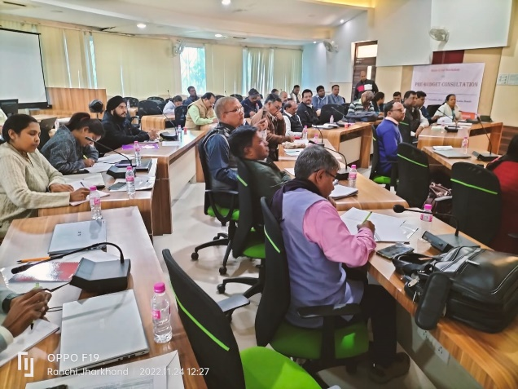
Following this Mr. Balram did the context setting. “Jan Budget Kaisa Ho” was his tagline to initiate the discussion. He stated that it should focus on people’s aspirations and hopes and Government to take appropriate actions on it and work accordingly. The budget should be targeted on ground realities and focus on the common people. Mr. Balram recapitulated the last year’s recommendations and informed all as to how some pertinent suggestions were taken up the Government in the most welcome manner. However, some others were provisioned but not implemented. Keeping all this in mind, the present budget shall be a demand from people’s side, their necessity and gaps to be looked. He also focused on the fact that the Government should implement the Constitutional commitment for its citizens.
It was suggested by the house that the budget should be tracked from day one so that clarity and transparency are maintained and tracking being a part of government’s work shall help in effective functioning and accurate governance within the system.
Following Mr. Ajit Singh, Director ViSWA, said that we need to focus on the budget outcomes and also track it accurately. We as citizens need to see how money is being utilized and are the real beneficiaries really getting benefit out of it. Budget recommendations should be in alignment with SDGs and HDI and the CSOs can monitor and hammer the Government to rectify its problems. He also stressed on the fact that Panchayats must also be encouraged to plan and prepare their own budget.
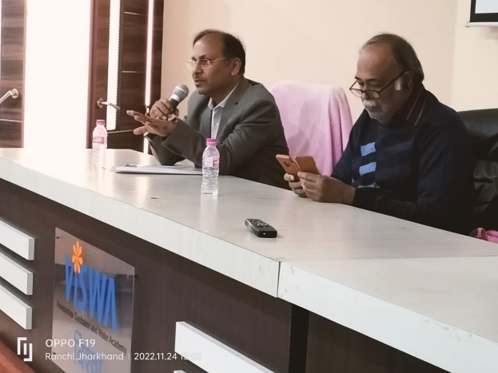
Prof. Dayal focused on revenue collection at State as we depend largely on Centre. Our devolution has decreased since 2019-2020. Covid-19 further aggravated the situation and Cess and Surcharge have also increased in the state. He also mentioned a few sources of revenue like excise, transport, property registration, commercial taxes etc. He also laid stress on the need of monitoring. He said that we are a revenue surplus state but here the institutional development is low. The recruiting agencies are not performing their jobs accordingly and they need to be strengthened based on quality rather than quantity. Focus must be on creation of State Finance Commission and its working mechanism. He also laid stress on the fact to make Jharkhand a medical and educational hub.
Next Prof. Sharan shared his views on budget. He said that such types of consultations should be frequent and not one-time activity. Analysis here is very important and recommendations to be put in public domain for visibility of all. When revenue does not come, expenditure is forcibly stopped and so we should focus on increasing the royalty and further it should be value based. Special grants to be made for those who are in the backward category. He also talked about leveraging environmental tax in order to safeguard our environment. He posed certain demands like:
- District level budgets to be had from Government.
- Revisiting the Vision Document prepared earlier and focusing on issues of importance.
- Being transparent in budget allocation and improving the outcome budget.
- PESA to be incorporated by State.
- Tourism prospect to be developed.
- Decentralization of budget for remote/ backward areas.
- Increasing revenues and prevention of leakages.
- State Finance Commission to be a priority.
- Preparing of special documents for those areas where money comes from other sources than budget like JSLPS, IFAD etc.
- Granting mines and minerals rights to Gram Sabha under the PESA.
- Revealing the expenditure in public domain and priority setting for the same.
- Formation of state Planning Board for monitoring and evaluation of budget as presently they are the weakest links.
- Data to be made accessible (in Excel Format rather than being in PDF).
- Public debts to be made public so that all can see and analyze.
He also laid stress on the fact that Government should in present times invest more on areas pertaining to water, pollution and encourage economic activities. Budget should be such that it completes an institution.

